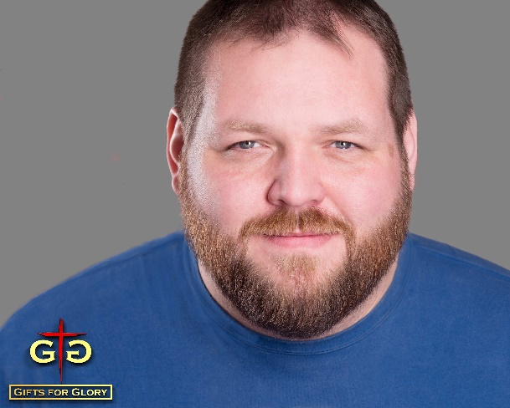
Dave Ebert is a former pro-wrestler, radio announcer, house parent, and one-time vacuum salesperson, who is now building a name in the Midwest as an improv comedian with a passion for improving the lives of those around him. Dave was born in Chicagoland but spent a majority of his life in southwestern Virginia.
Dave is currently pursuing credentialing with the Assemblies of God to be a licensed minister. He is married to his wife Bobbie Ebert, and they reside in Crest Hill, Illinois, with their three cats Trooper, Penny, and Kandi.
Find out more about Dave and his ministries at gifts4glory.com, or the improv ministry at wellversedcomedy.com.
Popular Quotes:
“I used to use comedy to hide who I was. Now, I use comedy to reveal who He is.”
“Making music is one of the most amazing ways to honor and glorify God. Our song is the sound of God’s people united in laughter.”
Links to find more:
Gifts for Glory Ministries: gifts4glory.com
Bio Page: https://gifts4glory.wixsite.com/gifts4glory/dave-ebert
Interview on Art & Faith Conversations podcast hosted by Libby John (2019): https://www.stitcher.com/podcast/art-faith-conversations/e/60237500
Testimony as shared on Moody Radio’s Karl and Crew Mornings Show (2018): https://youtu.be/6vYDmKoou20
Article in the Joliet, Illinois, Herald News (2017): https://www.theherald-news.com/lists/2017/09/13/615075ee9e824befabee6d4c6c05729d/index.xml?page=1
Alumni Article from Bluefield College (2014): http://www.bluefield.edu/article/alumnus-uses-comedy-to-share-gospel/

